**Identifying drivers of attrition through Key influencers visualization:**

1. Lack of Career Growth

2. Inadequate Compensation & Benefits

3. Poor Work-Life Balance

4. Managerial Issues

5. Better External Opportunities

6. Toxic or Misaligned Culture

7. Job Role Mismatch

**Recommendations to Reduce Attrition:**

1. Career Development & Internal Mobility

2. Managerial Training & Engagement

3. Compensation Benchmarking

4. Work-Life Balance Initiatives

5. Stay Interviews & Exit Analysis

**The key influencers visual has some limitations:**

* **Direct Query isn't supported.**
* **Live Connection to Azure Analysis Services and SQL Server Analysis Services is not supported.**
* **In our data model on live connection, we cannot use some visuals out of which Key Influencers is one.**

**For reference:**

[**https://learn.microsoft.com/en-us/power-bi/visuals/power-bi-visualization-influencers**](https://learn.microsoft.com/en-us/power-bi/visuals/power-bi-visualization-influencers)

**Other Visuals that can be used for analysis:**

**1. Density Plot**

* **Use for**: Showing correlation between two numerical variables

(e.g., Years of Experience vs. Attrition Rate)

* Example: **Salary vs. Attrition Count**
* **Job Description Length or Project Count vs. Attrition**
* **Remote Work Ratio vs. Attrition Rate**

1. The graph demonstrates how the distribution of monthly income differs between current employees and those who have left the organisation. The orange curve, which represents departing employees, has a smaller peak and is more dispersed, showing that the range of monthly income is wider for departing employees. Indicating that the range of Monthly Income is narrower for workers who are still working, the blue curve (representing employees who are still employed) has a higher peak and is more concave.

**Reference**: <https://medium.com/@bhadra_m/visualization-of-hr-employee-attrition-performance-1d1ff5cb4605>

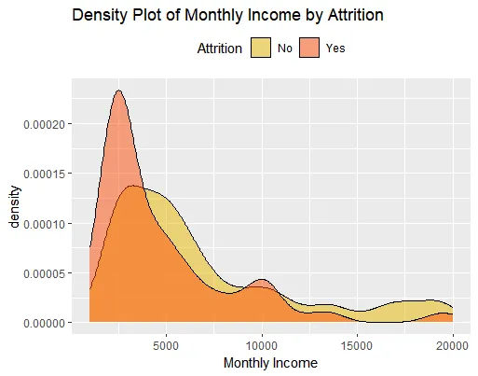

1. As seen in the chart above, the attrition is maximum between the age groups 28–32. The attrition rate keeps on falling with increasing age, as people look after stability in their jobs at these point of times. Also at a very younger age, i.e. from 18–20, the chances of an employee leaving the organization is far more- since they are exploring at that point of time. It reaches a break even point at the age of 21

**Reference**: <https://vivekrai1011.medium.com/hr-employee-attrition-e59700e5344f>

**Pyramid shifts impacting workforce dynamics:**

What is a Workforce Pyramid?

A workforce pyramid represents the distribution of employees across different experience levels

IOT is influencing the pyramid

**1. Automation of Routine Roles**

**2. Demand for Specialized Skills**

* Increased need for professionals skilled in:
  + IoT architecture
  + Embedded systems
  + Data analytics
  + Cybersecurity
* This shifts the pyramid toward **mid-to-senior technical roles**.

**3. Flattening of Hierarchies**

**4. Upskilling Pressure**

**Causes:**

* High attrition in mid-level roles due to lack of upskilling or career stagnation.
* Over-hiring at entry level without a clear growth path.
* Underinvestment in leadership development for digital transformation.

**Visuals:**

**1. Role Distribution Pie Charts**

* **Visual Type: Pie or donut chart**
* **Use Case: Workforce composition before and after flattening**
* **Insight: Shift from managerial to specialist roles**

**2. Productivity or Innovation Metrics Over Time**

* **Visual Type: Line chart or area chart**
* **Use Case: Tracking performance post-hierarchy flattening**
* **Insight: Correlation between structure and output**

**How is the model estimating coefficient:**

1. **Starting Point: Random Guesses**

* The model begins with some **random numbers** for each feature.
* These numbers (called **weights or coefficients**) tell the model how important each feature is for predicting attrition.

2. **Make Predictions and Check Accuracy**

* Using these random guesses, the model makes predictions for who will leave and who won’t.
* Then it compares its guesses with the actual data to see **how far off** it was.

3. **Loss Function = How Bad Were the Guesses?**

* The **log loss** measures the “badness” of the predictions.
* If the model predicted someone would stay but they actually left, that’s a mistake—and log loss tells the model how big the mistake was.

4. **Fix the Mistakes**

* Based on how bad each guess was, the model slightly adjusts the coefficients to improve future predictions.
* This process repeats over and over—correct, adjust, check, repeat.

5. **Iterations (Like Practice Rounds)**

* These repeats are called **iterations**.

Reference: <https://blog.enterprisedna.co/linear-regression-python/>

**Sandbox Visual in Power BI:**

Scenario:  
An organization faces high employee turnover and wants to experiment with different interventions—like changes to compensation, management style, training, or workload distribution—without risking disruption to real teams.

Sandbox Solution:  
A sandbox environment simulates the organizational structure, policies, and team dynamics using historical data or anonymized profiles. This lets HR analysts safely test how different strategies may impact attrition rates before applying them in the real world.

The End: